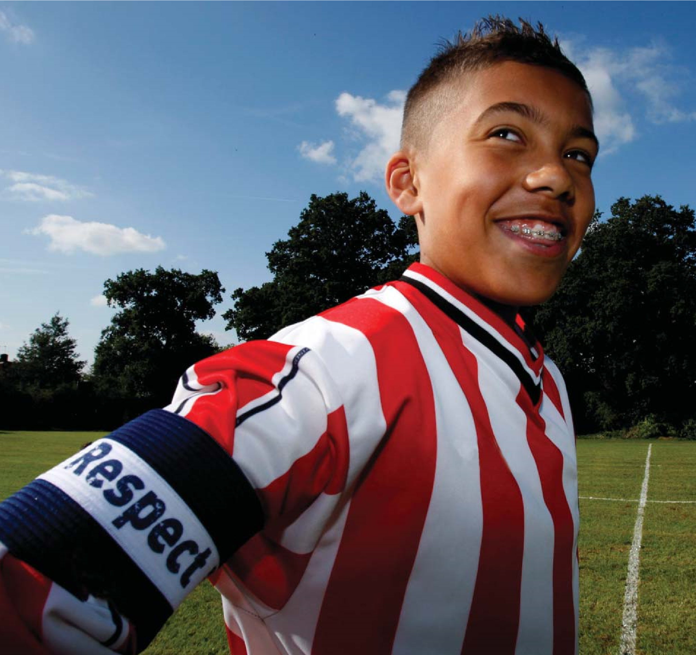
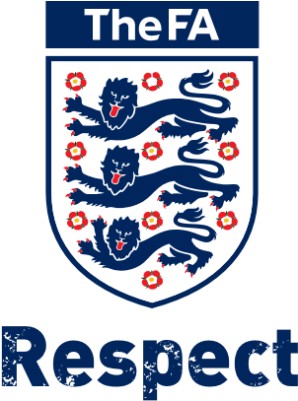
The FA Respect
CODE OF CONDUCT

YOUNG PLAYERS
WHEN PLAYING FOOTBALL I WILL:
- Always play to the best of my ability and for the benefit of my team
- Play fairly – I won’t cheat, dive, complain or waste time
- Respect my team-mates, the other team, the referee or my coach/manager
- Play by the rules, as directed by the referee
- Be gracious in victory and defeat – I will shake hands with the other team and referee at the end of the game
- Listen and respond to what my coach/team manager tells me
- Understand that a coach has to do what is best for the team and not one individual player
- Talk to someone I trust or the club welfare officer if I’m unhappy about anything at my club.
I understand that if I do not follow the code, any/all of the following actions may be taken by my club, county FA or The FA:
I MAY:
- Be required to apologise to my team-mates, the other team, referee or team manager
- Receive a formal warning from the coach or the club committee
- Be dropped or substituted
- Be suspended from training • Be required to leave the club.
IN ADDITION:
- My club, County FA or The FA may make my parent or carer aware of any infringements of the Code of Conduct
- The FA/County FA could impose a fine and suspension against my club.

SPECTATORS
We all bear a collective responsibility to set a good example and help provide a positive environment in which children can learn and enjoy the game. Play your part and observe The FA’s Respect Code of Conduct for spectators at all times.
I WILL:
- Remember that children play for FUN
- Applaud effort and good play as well as success
- Respect the Referee’s decisions even when you don’t agree with them
- Appreciate good play from whatever team it comes from
- Remain behind the touchline and within the Designated Spectators’ Area
- Let the coach do their job and not confuse the players by telling them what to do
- Encourage the players to respect the opposition, referee and match officials
- Support positively and offer players encouragement not criticism
- Never engage in, or tolerate offensive, insulting or abusive language or behaviour
I understand that if I do not follow the Code, any/all of the following actions may be taken:
I MAY BE:
- Issued with a verbal warning from a club or league official
- Required to meet with the club, league or CFA Welfare Officer
- Required to meet with the club committee
- Obliged to undertake an FA education course
- Obliged to leave the match venue by the club
- Requested by the club not to attend future games
- Suspended or have my club membership removed • Required to leave the club along with any dependents.
IN ADDITION:
- The FA/County FA could impose a fine and/or suspension on the club.

COACHES, TEAM MANAGERS AND CLUB OFFICIALS
We all bear a collective responsibility to set a good example and help provide a positive environment in which children can learn and enjoy the game. Play your part and observe The FA’s Respect Code of Conduct at all times.
ON AND OFF THE FIELD, I WILL:
- Use my position to set a positive example for the young people I am responsible for
- Show respect to others involved in the game including match officials, opposition players, coaches, managers, officials and spectators
- Adhere to the laws and spirit of the game
- Promote Fair Play and high standards of behaviour
- Respect the match official’s decision
- Never enter the field of play without the referee’s permission
- Never engage in, or tolerate, offensive, insulting or abusive language or behaviour
- Be gracious in victory and defeat.
WHEN WORKING WITH PLAYERS, I WILL:
- Place the well-being, safety and enjoyment of each player above everything, including winning
- Never engage in or tolerate any form of bullying
- Encourage each player to accept responsibility for their own behaviour and performance
- Ensure all activities I organise are appropriate for the players’ ability level, age and maturity
- Co-operate fully with others in football (e.g. officials, doctors, physiotherapists, welfare officers) for each player’s best interests.

I understand that if I do not follow the Code, any/all of the following actions may be taken by my club, County FA or The FA:
I MAY BE:
- Required to meet with the club, league or County Welfare Officer
- Suspended by the club from attending matches
- Suspended or fined by the County FA • Required to leave or be sacked by the club.
IN ADDITION:
- My FA Coaching Licence may be withdrawn.

MATCH OFFICIALS
We all have a responsibility to promote high standards of behaviour in the game. The behaviour of the match officials has an impact, directly and indirectly, on the conduct of everyone involved in the game – both on the pitch and on the sidelines.
Play your part and observe The FA’s Respect Code of Conduct of match officials at all times.
I WILL:
- Be honest and completely impartial at all times
- Apply the Laws of the Game and competition rules fairly and consistently
- Manage the game in a positive, calm and confident manner
- Deal with all instances of violence, aggression, unsporting behaviour, foul play and other misconduct
- Never tolerate offensive, insulting or abusive language or behaviour from players and team officials
- Support my match official colleagues at all times
- Set a positive personal example by promoting good behaviour from players and team officials
- Set a positive personal example by promoting good behaviour and showing respect to everyone involved in the game
- Communicate with the players and encourage fair play
- Respond in a clear, calm and confident manner to any appropriate request for clarification by the team captains
- Prepare physically and mentally for each match
- Complete and submit, accurate and concise reports within the time limit required for games in which I officiate.
I understand that if I do not follow the Code, any/all of the following actions may be taken:
I MAY BE:
- Required to meet with The FA /County FA Refereeing Official
- Required to meet with The FA/County FA Refereeing Committee.

ADULT PLAYERS
We all have a responsibility to promote high standards of behaviour in the game. Play your part and observe The FA’s Respect Code of Conduct for players at all times.
ON AND OFF THE FIELD, I WILL:
- Adhere to the Laws of The Game
- Display and promote high standards of behaviour
- Promote Fair Play
- Always respect the match official decisions
- Never engage in public criticism of the match officials
- Never engage in offensive, insulting or abusive language or behaviour
- Never engage in bullying, intimidation or harassment
- Speak to my team-mates, the opposition and my coach/manager with respect
- Remember we all make mistakes
- Win or lose with dignity. Shake hands with the opposing team and the referee at the end of every game.
I understand that if I do not follow the Code, any/all of the following actions may be taken:
I MAY:
- Be required to apologise to team-mates, the other team, referee or team manager
- Receive a warning from the coach
- Receive a written warning from the club committee
- Be required to attend an FA education course
- Be dropped or substituted
- Be suspended from training
- Not be selected for the team
- Be required to serve a suspension
- Be fined
- Be required to leave the club.
IN ADDITION:
- The FA/County FA could impose a fine and/or suspension on the club.
NAME | SIGNATURE

TheFA.com/Respect

The Football Association Wembley Stadium,
Wembley, London HA9 0WS
Telephone
+44 (0)844 980 8200 Facsimile
+44 (0)844 980 0682
FA Charter Standard enquiries
+44 (0)845 210 80 80
Email info@TheFA.com
Visit
www.TheFA.com/YourGame
The FA Respect
CODE OF CONDUCT

